IDS 705 Final Report

The Hidden Struggle: Data-Driven Detection of Student Depression
Team Members:
Dhariwala, Nakiyah
Gao, Jiaxin
Shah, Syed Huma
Xu, Fan
Team Identifier: Pangolin

Abstract
Student mental-health warning signs often surface long before clinical thresholds are crossed. Leveraging the 2013 StudentLife longitudinal cohort, we modelled weekly PHQ-9 depression scores from 35 smartphone-sensed and self-reported features. After rigorous cleaning, ordinal re-coding, and outlier removal, we benchmarked three modelling tiers: an interpretable OLS baseline that achieved an R² of 0.74, a Random-Forest ensemble that raised performance to 0.89, and a tuned XGBoost model that attained the best R² of 0.896. Both tree models dramatically out-performed the linear baseline, confirming substantial non-linear signal. Explainability tools (gain & permutation importance, SHAP, PDPs) converge on four dominant drivers: GPA, momentary sadness, extreme openness to experience, and minimal daily routine. Raising GPA from a C to a B yields the steepest risk reduction; sadness elevates risk almost linearly; very high openness is associated with higher predicted depression, while even modest routine is protective. These insights point to concrete, data-driven interventions—academic coaching for sub-2.8 GPAs, low-barrier mood check-ins, and resilience resources for highly “experiential” students—illustrating how mobile sensing combined with interpretable machine-learning can guide campus mental-health strategy.

Introduction
In this project, we are attempting to understand how behavioral, social, and environmental factors influence students' mental health. Specifically, we aim to identify the strongest predictors of depression levels using machine learning on survey data.
Identifying depression in students is crucial, as these conditions can significantly impact academic performance, social interactions, and overall well-being. High-functioning depression–characterized by symptoms like fatigue, changes in appetite, and poor concentration without overt distress–often goes unrecognized. The StudentLife dataset, which collects continuous smartphone sensor data and self-reports from students, provides a valuable opportunity to detect such subtle manifestations of depression. By analyzing patterns in sleep, activity levels, and social interactions, we can uncover behavioral indicators associated with high-functioning depression, facilitating early identification and intervention. What excites us most is the potential of this research to shape proactive solutions rather than reactive ones, ensuring students get the help they need when they need it most.

Background
There have been a number of studies looking at how different lifestyle factors affect student mental health. One such paper is Baba et al. which looks at predicting mental health issues in Japanese students with ML techniques. The variables looked at include demographics, survey responses (e.g., campus life concerns), and answering time metrics (response time). Models like logistic regression, random forest, and LightGBM were tested, with LightGBM achieving the highest performance (Matthews correlation coefficient ≈ 0.97–0.99). Also, in another study Random Forests and boosting yielded the highest accuracy for predicting stress and depression outcomes [13]. The key predictors were found to be self-reported campus life stressors. Answering time variables added marginal predictive value, but the study emphasized the feasibility of using annual survey data and ML for cross-year mental health prediction.

Srividya et al. applies ML to classify mental health states using questionnaire data. Targeting high school students, college students, and working professionals, the authors designed a 20-item survey to categorize respondents into "mentally distressed," "neutral," or "happy." Clustering (K-means, hierarchical) identified three groups, validated via Mean Opinion Score. Classifiers like SVM, KNN, and random forest were tested, with ensemble methods (random forest, bagging) achieving 90% accuracy. SVM and KNN also performed well. The study highlighted ML’s potential for scalable mental health screening and suggested future work integrating physiological data.
Both studies underscore ML’s efficacy in mental health prediction, leveraging different data sources (existing surveys vs. custom questionnaires) and emphasizing interpretability (SHAP values, cluster validation).

Data
Our dataset comprises daily records from 48 undergraduate and graduate students who participated in the 10-week StudentLife study. For our experiments we looked at 36 variables that captured behavioral patterns (e.g., activity levels, sleep duration, physical exercise), academic engagement (e.g., class attendance, assignment deadlines, GPA), and mental states (e.g., mood, stress, anxiety). While most features were recorded daily, some such as GPA or PHQ-9 score were static variables. After removal of incomplete or missing records through data cleaning, the final dataset included approximately 2,560 usable samples (i.e., 48 students × ~70 days), which varied based on each student's data completeness.
Boxplots were used to visualize the data distribution The plots revealed varying degrees of skewness, variability, and outliers across student-reported behaviors, academic metrics, and emotional states.
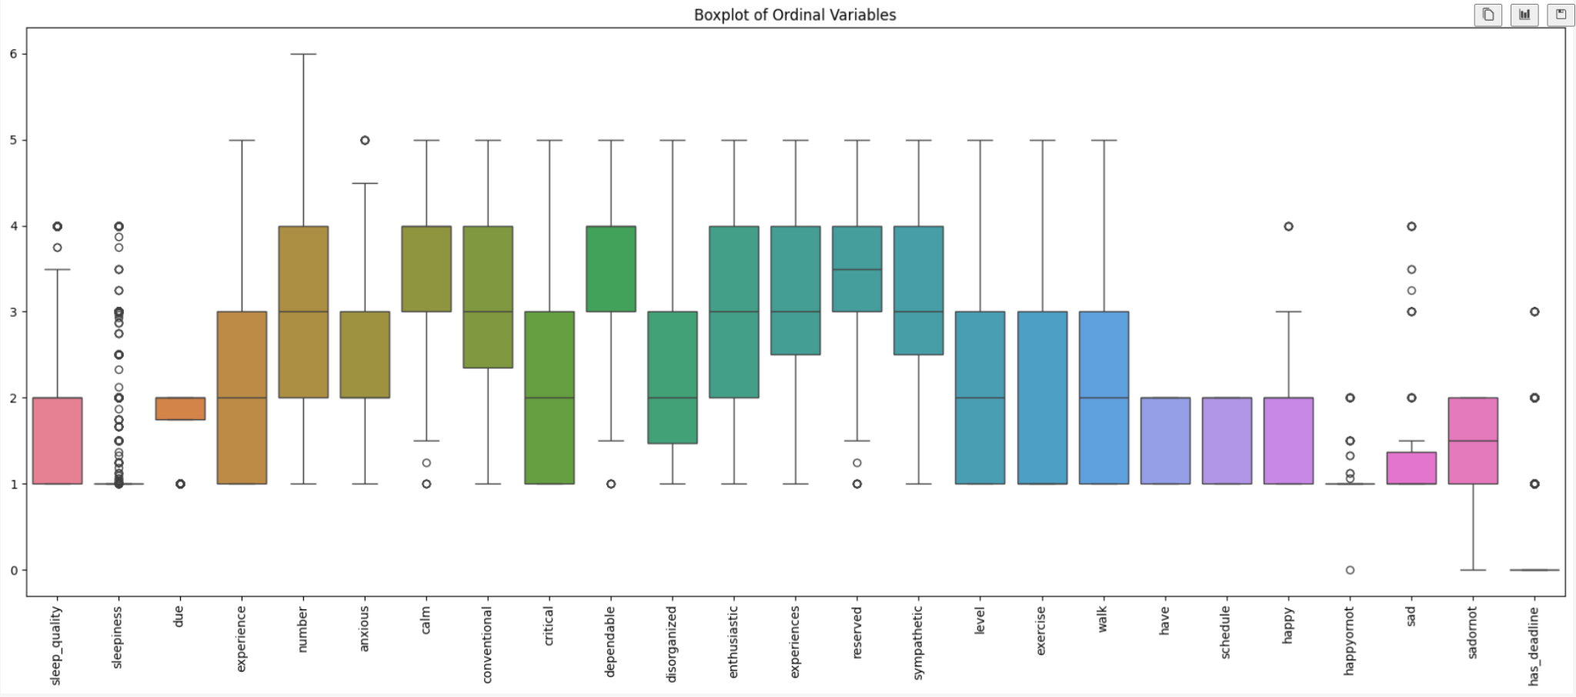
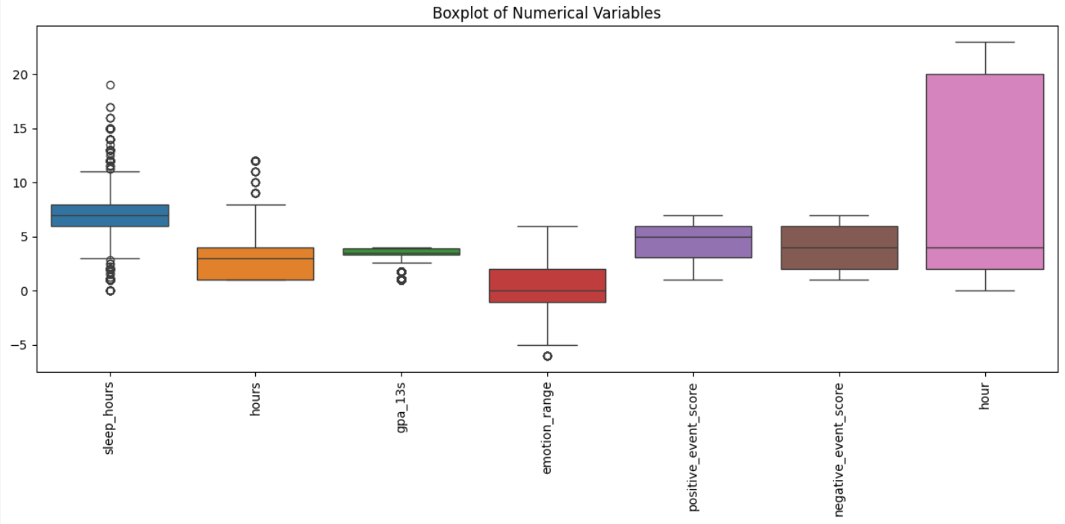
To address sparsity across the ten-week period, we applied different preprocessing and imputation strategies based on model type. For regression models, we aggregated EMA (ecological momentary assessment) variables weekly by user ID and datetime to reduce day-to-day noise and synchronize modalities. Within each user-week block, missing values were forward- and backward-filled in time order, and rows with over 70% missing data were dropped to maintain quality. In contrast, for sequence-based models (e.g., LSTM), we aggregated data at the daily level and then applied forward- and backward-filling across each student’s timeline to preserve temporal continuity while capturing fine-grained behavioral patterns.
The outcome variable used was PHQ-9 score (depression score), which serves as a proxy for depression severity and is widely used in clinical assessments to evaluate mental health status.
Flowchart
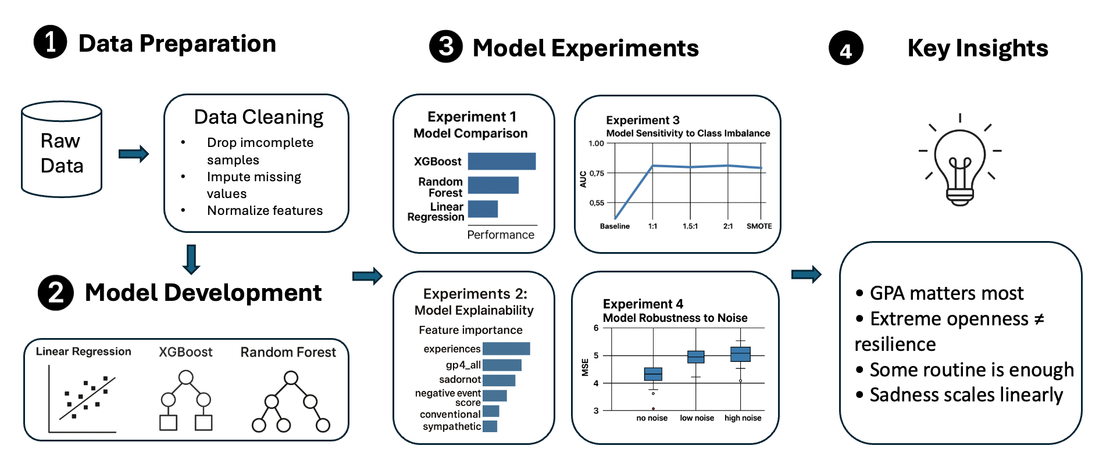

Experiments

Experiment 1: Model Comparison
A linear model (Ordinary Least Squares) was fitted first to the data as a simple, interpretable baseline. Linear regressions have a long precedent in digital-phenotyping and EMA studies; the original StudentLife work used OLS to link phone-sensing features to depression score (PHQ-9 scores) [10], and later analyses have shown that many linear methods can achieve AUCs around 0.79—on par with tree-based learners—for depression risk prediction in similar cohorts [11]. These linear models are easy to interpret and have precedent in prior literature – for example, the StudentLife study initially examined straightforward correlations and linear regressions between smartphone sensor data and mental health measures [10]. Such approaches are considered reasonable baselines because early work often relied on them to establish fundamental associations [10].

To capture nonlinear relationships and interactions, XGBoost is incorporated, a gradient boosted tree ensemble, given its ability to model complex patterns and its strong performance in many prediction tasks [12]. Ensemble tree-based models are indeed popular in mental health analytics; for instance, a recent student well-being study tested various algorithms (GLMs, k-NN, Naïve Bayes, neural nets, etc.) and found that Random Forests and boosting yielded the highest accuracy for predicting stress and depression outcomes [13]. Moreover, tree-based models provide valuable interpretability, which is crucial for our goal of understanding the underlying data patterns.pre

Prior to fitting any of these models, we re-encoded key EMA items (e.g. “experience,” “level,” etc.) into truly increasing ordinal scales. Both RandomForestRegressor and XGBoost were then tuned with 5-fold cross-validation over hyperparameter grids (n_estimators, max_depth, subsample/colsample, learning_rate) to ensure robust generalization.

This simple linear model benchmark, alongside the more complex ensemble models (XGBoost and Random Forest), frames a comprehensive model comparison for our analysis.

Model | Test MSE | Test R² | Adj R²
OLS (baseline) | 8.48 | 0.740 | 0.732
XGBoost (tuned) | 3.38 | 0.896 | 0.894
Random Forest (tuned) | 3.61 | 0.889 | 0.887
Table 1: Performance Comparison across different models

The performance table 1 above compares the performance of different models with their mean squared error, R² on the test set and the adjusted R² values. The OLS baseline yielded an MSE of 8.48 and R² = 0.740 (adj R² = 0.732), confirming that simple additive effects explain roughly three-quarters of the variance in weekly depression score. Introducing a tuned RandomForestRegressor cut the MSE nearly in half to 3.61 and lifted R² to 0.889 (adj R² = 0.887), demonstrating that bagged trees capture additional non-linear structure. Finally, our grid-tuned XGBoost model achieved the lowest error (MSE = 3.38) and highest out-of-sample R² = 0.896 (adj R² = 0.894).
Examining the full OLS coefficient estimates reveals that four self-report and academic features drive the linear signal. GPA (gpa_all) exhibits the strongest protective effect (β = –7.06, p < 0.001), meaning each one-point GPA increase corresponds to a 7-point drop in predicted depression score. Openness to experience (experiences; β = 1.08, p < 0.001) and momentary sadness (sad; β = 0.65, p < 0.001) both raise depression scores, while minimal routine (conventional; β = –0.18, p < 0.001) and dependability (dependable; β = –0.51, p < 0.001) confer modest protection. These linear associations align closely with our ensemble explainability results. Global SHAP and permutation‐importance rankings (Fig. 4) consistently highlight GPA, sadness, openness, and routine preference as the top four drivers.
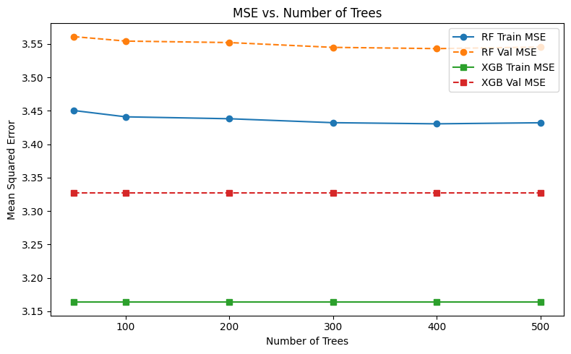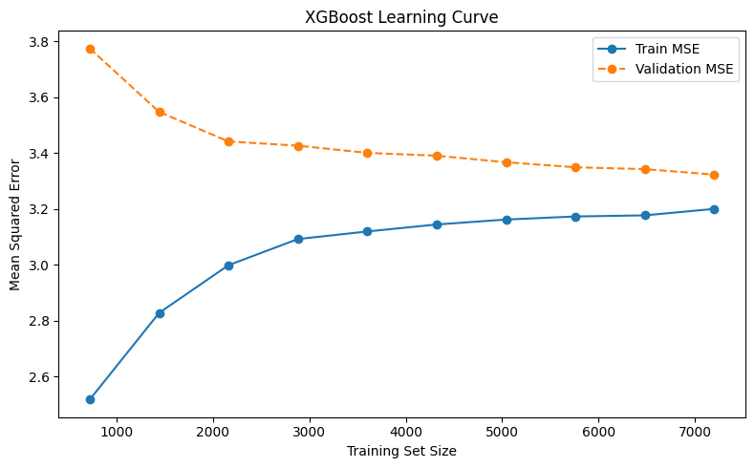
Figure 1: MSE vs. Number of Trees and XGBoost Learning Curve
Figure 1 illustrates that for both Random Forest and XGBoost, training and validation errors converge by around 200 trees and remain nearly constant thereafter. The small gap between curves suggests that adding more trees yields little extra benefit and that, once properly tuned, neither model overfits. The learning curves in Figure 1 reveal that as we increase the training set size, validation error steadily declines and the gap between training and validation scores narrows, indicating that more data continues to improve generalization. However, the flattening of both curves beyond roughly 5,000 samples suggests that further increases in dataset size are likely to yield only marginal performance gains.
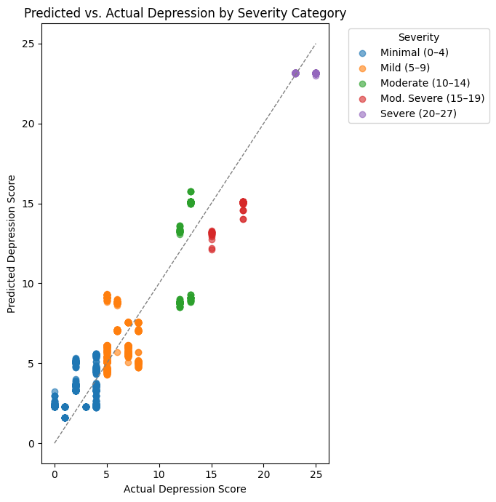

Fig 2: Predicted‑vs‑actual plot for xgboost model
Figure 2 shows predicted versus actual depression scores, with points color-coded by clinical severity (minimal, mild, moderate, moderately severe, and severe). The strong clustering of all categories along the 45° identity line indicates that the model accurately recovers depression severity across the spectrum. Minimal (0–4) and mild (5–9) cases lie almost exactly on the diagonal, with very little scatter. Moderate (10–14) and moderately severe (15–19) points also track closely, though with slightly greater variance. The few severe cases (20–27) exhibit a small tendency toward underprediction—predicted scores fall just below the true values—but remain near the line. In sum, the model delivers consistent, unbiased estimates across all severity brackets, without systematic over- or underestimation in any particular range.
These results show that while simple additive models explain a substantial fraction of variance in weekly depression scores (~ 74 %), ensemble tree methods unlock the remaining non-linear and interactive structure to push explained variance to ~ 90 %.

Experiment 2: Model Explainability
Understanding why our XGBoost model makes the predictions it does is just as important as how well it predicts. By interrogating the model’s internal logic, we can translate abstract feature‐importance scores into actionable insights—pinpointing which behaviors to target in early‐intervention programs. We ran our tuned XGBoost regressor through explainability analyses and then distilled the key takeaways below.

Our explainability analyses converge on four actionable findings that drive students’ depression predictions:

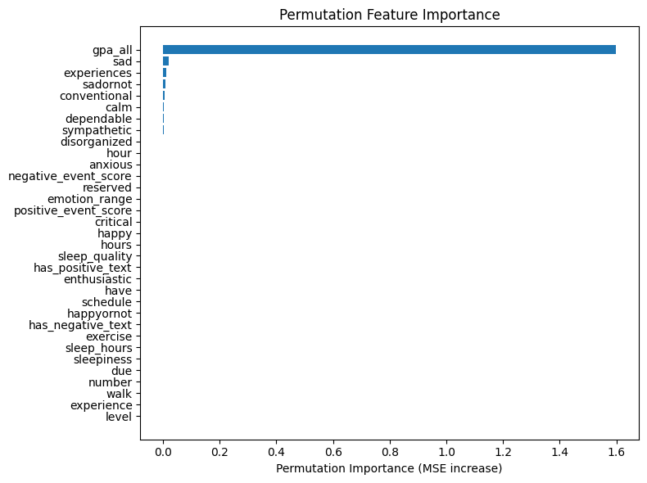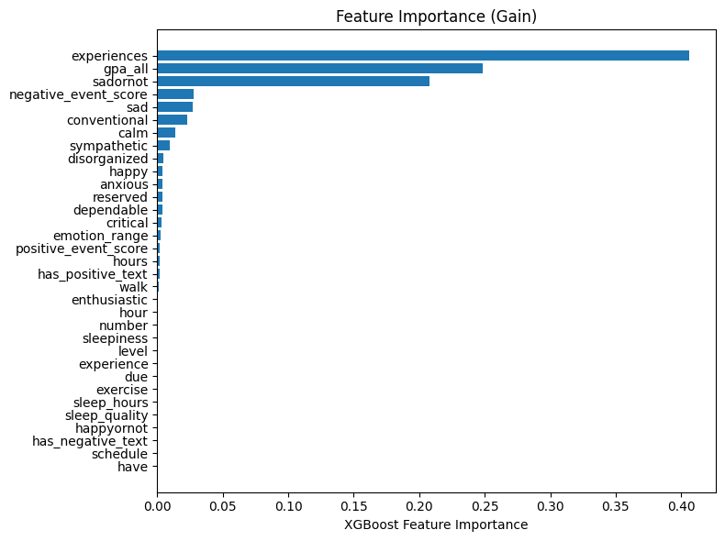
Fig 3: Global Importance Ranking

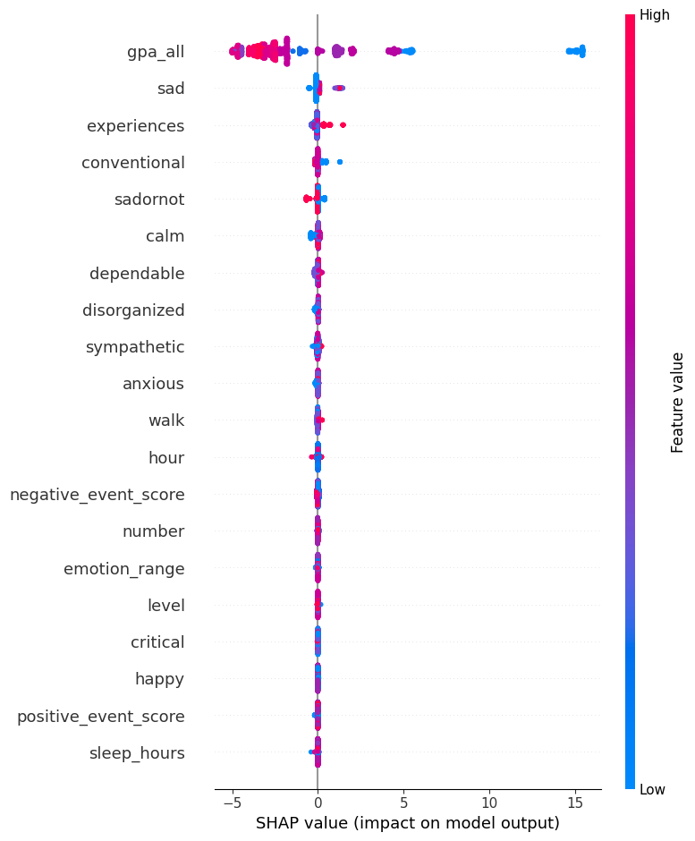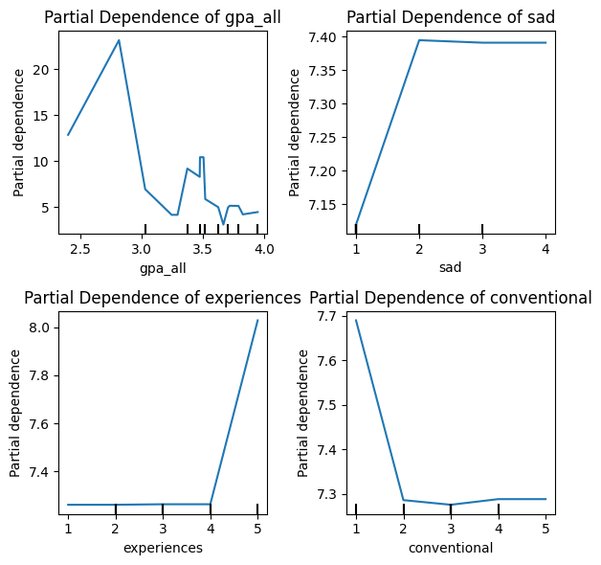
Fig 4: Beeswarm plot showing the Fig 5: Partial‑dependence curves
SHAP Summary on test‐set cases (N≈1,000)

- Academic performance is the strongest predictor of lower depression scores. Both gain‐ and permutation‐based importance (Fig. 3) place GPA far above all other predictors. The partial‐dependence curve shows that raising GPA from roughly 2.4 to 2.8 produces the steepest reduction in predicted depression, with benefits that plateau beyond about 3.1—indicating that helping students move from a C-average into a solid B may yield the greatest mental-health gain. This pattern is also seen in the SHAP summary (Fig. 4), where high GPA values generate the largest negative contributions to individual predictions.

- Sadness adds risk nearly linearly. High sadness pushes scores upward, almost without exception (Fig. 3). Each one-point rise in momentary sadness increases predicted depression by roughly 0.5 points (Fig. 5). This steady, proportional effect underscores the importance of regular mood check-ins as even small upticks in sadness carry meaningful depression risk.

- Openness carries risk only at the extremes. “Openness to experience” (experiences) shows no effect up to moderate levels, then a sharp jump in predicted score at the highest two ratings (Fig. 5), suggesting that extreme openness correlates with higher predicted depression risk–—high openness may predispose individuals to seek novel or emotionally intense experiences, which can amplify stress and rumination [14]. Moreover, Openness and Routine (Fig. 4 and 5) exhibit more mixed SHAP distributions, indicating their effects depend on interactions with other features (e.g., high openness elevates risk primarily when sadness is also high).

- Minimal routine is sufficient for mental health. Moving from “not at all conventional” to “slightly conventional” lowers predicted depression modestly (Fig. 4 and 5), but pushing routine preference any further produces no extra benefit—seen as a one‐step drop and subsequent flat PDP curve. This aligns with research on social zeitgebers, which shows that even establishing minimal regular daily activities (sleep, meals, social interactions) can stabilize mood and reduce depressive symptoms, whereas adding more rigidity yields diminishing returns [15].

GPA, sadness, openness to new experiences, and routine preference together account for the vast majority of predictive power. Collectively, these explainability analyses from global‐importance rankings through SHAP value distributions to partial‐dependence curves reveal how our model weighs different behavioral and academic factors in predicting depression. By exposing key relationships we gain a nuanced understanding of what drives elevated depression scores. Though not prescriptive, this deeper insight into the model’s “reasoning” can inform the development of more targeted, evidence-based mental-health strategies on campus.

Experiment 3: Model Sensitivity to Class Imbalances
The dataset included 9,003 samples, of which 1,812 students (20.1%) were classified as experiencing moderate to severe depression (PHQ-9 ≥ 10), and 7,191 students (79.9%) as None/Mild. This yielded a class imbalance ratio of approximately 1:4, underscoring the need to assess how model performance is affected by rebalancing strategies. To evaluate how class imbalance affects model performance in detecting students at risk of depression, we tested five versions of both the XGBoost model and a Random Forest model. First, we stratified the dataset into an 80/20 training-test split to preserve the original class imbalance (approximately 1:4). Each model was then trained under the following conditions:
- On the original imbalanced dataset (baseline)
- After undersampling the majority class (None/Mild) at three different ratios (1:1, 1.5:1, 2:1)
- After oversampling the minority class (Moderate+) using SMOTE
Table 2: XG Boost
Sampling | Accuracy | Precision | Recall | AUC
Baseline | 94.8% | 1.00 | 74.3% | 0.9902
1:1 Undersample | 95.2% | 0.806 | 100% | 0.9911
1.5:1 Undersample | 95.0% | 0.806 | 98.9% | 0.9906
2:1 Undersample | 94.1% | 0.921 | 77.3% | 0.9903
SMOTE Oversample | 95.2% | 0.806 | 100% | 0.9912

Under the baseline scenario, XGBoost demonstrated great overall accuracy (94.8%) and perfect precision (1.00) but poor recall (74.3%), revealing a common failure mode when models are trained on imbalanced data. Specifically, the model overlearned the majority class, resulting in underdetection of clinically significant minority cases.
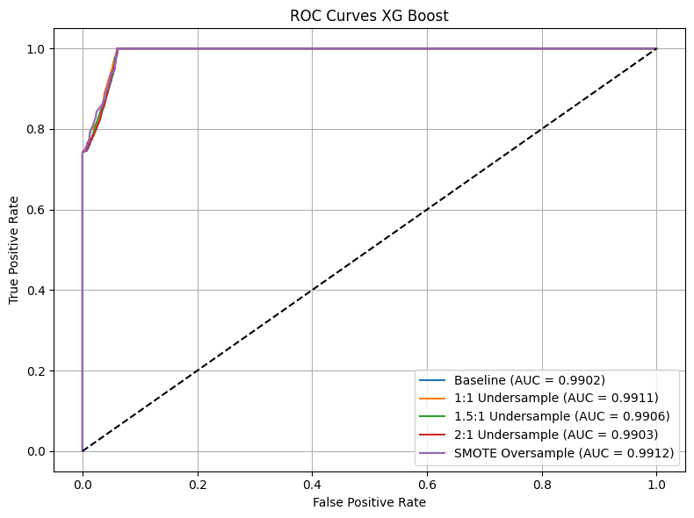
Fig 6: Testing imbalance for XGBoost

Majority class undersampling significantly enhanced recall metrics. The model perfectly recognized all at-risk students (recall = 1.00) at the 1:1 undersampling ratio, although precision was slightly reduced (0.81). Undersampling at ratios of 1.5:1 and 2:1 traded off between precision and recall, achieving high precision levels (80–92%) with a limited decline in recall relative to the 1:1 approach. Oversampling using SMOTE, on the other hand, performed best for XGBoost, with perfect recall (1.00) and strong precision (0.81), as well as highest AUC (0.9912) among all the sampling techniques. These results suggest that SMOTE performed well to enhance XGBoost's sensitivity to the minority class without losing much specificity.
Table 2: Random Forest
Sampling | Accuracy | Precision | Recall | AUC
Baseline | 92.4% | 0.855 | 74.9% | 0.9759
1:1 Undersample | 95.2% | 0.806 | 100% | 0.9920
1.5:1 Undersample | 95.2% | 0.806 | 100% | 0.9917
2:1 Undersample | 94.8% | 1.00 | 74.3% | 0.9918
SMOTE Oversample | 92.4% | 0.727 | 100% | 0.9913

On the other hand, Random Forest baseline performance was comparatively weaker, with lower overall accuracy (92.4%) and AUC (0.9759) relative to XGBoost. Although precision (0.85) was reasonable under imbalance, recall remained limited at 74.9%, again illustrating the model's reduced sensitivity to the minority class without intervention.
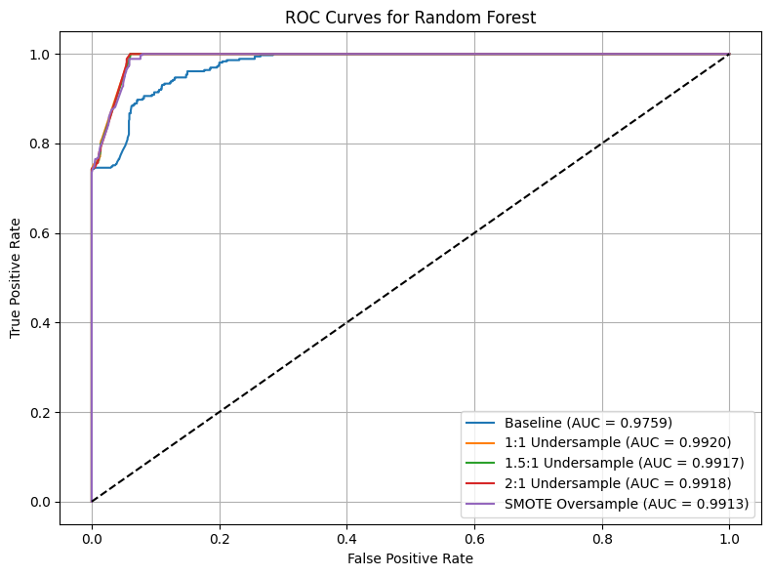
Fig 7: Testing Imbalance for OLS model
Undersampling the majority class substantially enhanced Random Forest’s classification performance. All undersampling strategies (1:1, 1.5:1, 2:1) achieved near-perfect or perfect recall (≥ 0.99), with balanced precision values between 80% and 100%. In particular, the 1:1 undersampling strategy produced the highest AUC (0.9920), indicating that Random Forest benefited significantly from real-data resampling.
By contrast, oversampling with SMOTE produced mixed outcomes. Although recall remained perfect (1.00), precision declined to 0.73, and overall accuracy fell relative to the baseline. These findings suggest that Random Forest may be more sensitive to oversampling artifacts compared to XGBoost, potentially due to its reliance on bootstrap aggregation of samples.
Across both models, class rebalancing strategies clearly improved the detection of students at risk for depression. However, XGBoost consistently outperformed Random Forest across key metrics including AUC, precision, and recall — particularly under both baseline and oversampled conditions. While Random Forest showed strong gains with undersampling, its performance was more volatile, especially under SMOTE, where precision dropped substantially. XGBoost not only achieved top recall and AUC, but also demonstrated greater stability and generalizability across sampling methods, making it the preferred model for handling class imbalance in this task. These results suggest that boosting-based models like XGBoost are better suited for imbalanced clinical prediction problems, particularly when oversampling techniques are required.

Experiment 4: Model Robustness to Noise
In real-world EMA settings, input data can be subject to various forms of bias, including self-report bias, recall inaccuracies, and sensor inconsistencies, which can introduce noise into the data. Transcript GPA is recorded to two decimals, yet in practice it can shift by a few hundredths when new grades post or when students mis-report it. We therefore added zero-mean Gaussian noise N (0, 0.05²)—roughly ±0.10 GPA at one standard deviation—to mimic realistic rounding errors and minor reporting drift while preserving the bell-shaped distribution typical of grade data. For ordinal variables (e.g., experiences, 1–5), EMA responses are selected on a phone; the most common error is tapping the adjacent button or re-interpreting the scale one step differently on a hectic day. A ±1 jitter (clipped to 1–5) reproduces exactly that single-category slip without creating impossible values. The binary flags (e.g., sadornot, schedule, have, has_negative_text) are yes/no variables that can flip because of momentary recall lapses. Randomly toggling 0 ↔ 1 (or 1 ↔ 2 in our coding) captures that simplest form of mis-labelling.
This approach facilitates the evaluation of the model's resilience to general data unreliability, a critical consideration for its deployment in uncontrolled, real-world environments. We identified two groups of features based on gain-based importance scores from the trained XGBoost model (Figure 5 in Experiment 2). The top three features—experiences, gpa_all, and sadornot—were classified as highly influential due to their strong predictive contribution and theoretical relevance to depression outcomes. Conversely, the bottom three features—have, schedule, and has_negative_text—were identified as less relevant given their minimal contribution to the model. This selection approach reflects the model's internal feature prioritization and supports targeted robustness testing.
To assess model resilience, noise was introduced to each feature based on its data type. For the continuous variable gpa_all, Gaussian noise was sampled from a normal distribution 𝑁(0, 0.05). The ordinal variable experiences was perturbed with discrete ±1 noise and clipped to the range [1, 5]. For binary-coded variables with values in [1, 2]—including sadornot, schedule, and have—random perturbations of ±1 were applied, and the values were clipped to remain within [1, 2]. The binary variable has_negative_text, with values in [0, 1], was similarly perturbed with ±1 noise and clipped to [0, 1]. These manipulations simulate common forms of reporting errors or measurement inconsistencies observed in ecological momentary assessment (EMA) studies.This experimental setup enables a systematic examination of the models’ sensitivity to feature noise. To quantify the performance degradation after noise injection, we evaluated both models using MSE and R² score.
For XGBoost model:

XGBoost Model | MSE | % change in MSE | R² | % change in R²
No Noise | 3.3773 | / | 0.8962 | /
Noise on experiences, gpa_all, sadornot | 3.6537 | 8.17 | 0.8878 | -0.94
Noise on have, schedule, has_negative_text | 3.3609 | -0.49 | 0.8968 | 0.07

Fig 8: Noise results on Xgboost
Adding noise to the top-3 most important features slightly reduced model performance, increasing MSE by 8.17% and decreasing R² by 0.94%. In contrast, noise added to the least important features had minimal impact, with a small MSE drop and a slight R² improvement, showing the model’s robustness to irrelevant feature perturbations.
For Random Forest model:

Random Forest Model | MSE | % change in MSE | R² | % change in R²
No Noise | 3.6133 | / | 0.8891 | /
Noise on experiences, gpa_all, sadornot | 4.0533 | 12.16 | 0.8756 | -0.21
Noise on have, schedule, has_negative_text | 3.6056 | -1.52 | 0.8893 | 0.02

Fig 9: Noise results on Random Forest
Similarly, adding noise to the top-3 important features resulted in a performance drop, with MSE rising by 12.16% and R² falling by 0.21%. In contrast, noise on the least important features had minimal impact, as R² slightly increased and MSE decreased, showing the model’s resilience to uninformative noise.
Compared to Random Forest, the XGBoost model demonstrated greater robustness to noise added to important features, showing a smaller increase in MSE (+8.17% vs. +12.16%) and a smaller drop in R² (-0.94% vs. -1.52%). Both models remained stable when noise was added to the least important features. These results suggest that while Random Forest performs reasonably well, XGBoost is more resilient to perturbations in critical inputs.

Conclusion
Our analysis shows that self-report EMA features become highly predictive once models can capture non-linearities and interactions. A simple OLS baseline accounted for only about a quarter of the variance, and even after cleaning plateaued at R² ≈ 0.74. Adding ensemble structure closed most of the remaining gap: a tuned Random Forest reached R² ≈ 0.89, and a still-more flexible XGBoost pushed performance to R² ≈ 0.90. The jump from linear to tree-based models confirms that rich combinations of term GPA, momentary sadness, extreme openness, and basic routine features drive depression scores in ways a purely additive model cannot capture.
From our explainability analyses—feature‐importance rankings, SHAP values, and partial‐dependence plots—we distilled three core insights:
- Academic performance (GPA) is the single strongest protective factor: modest improvements in low GPAs yield large reductions in predicted depression, though gains beyond a solid B‑average show diminishing returns.
- Routine preference (“conventional”) exhibits a threshold effect: establishing even minimal daily structure reduces depression risk, but further rigidity confers no extra benefit.
- Personality dimensions behave counterintuitively in context: extreme openness to experience correlates with higher predicted depression, suggesting highly engaged students may also face greater emotional sensitivity or performance pressure.
To maximize mental‑health impact while promoting academic success, campus health services should focus academic coaching, tutoring, and time‑management resources on students with GPAs below approximately 2.8, develop low‑barrier routines—such as fixed class and study schedules and regular meal reminders—for all students, particularly those reporting chaotic daily patterns, and offer tailored stress‑management workshops and peer‑support groups for high‑openness learners, who may need tools to balance enthusiasm with self‑care. By translating our predictive and interpretive findings into these concrete strategies, institutions can deploy data‑driven, targeted interventions that both bolster academic performance and safeguard students’ mental well‑being.

Roles
Data exploration and cleaning:
- Project idea proposal and dataset exploration by Nakiyah
- Input variable cleaning by Nakiyah and Fan
- Output variable research, identification and preprocessing by Cindy
Data exploration and feature extraction:
Variable filtering, data transformation, and missing value imputation by Fan, Nakiyah, Cindy and Huma (for different models)
Building and training the machine learning model and performing the results analysis:
- LSTM model by Nakiyah
- Regression model by Fan
- XGBoost and Random Forest model by Huma
Experiments:
- Experiment 1: Model Comparison by Huma and Fan
- Experiment 2: Model Explainability by Huma
- Experiment 3: Model Sensitivity to Class Imbalances by Nakiyah
- Experiment 4: Model Robustness to Noise by Cindy

References
- Baba A, Bunji K. Prediction of Mental Health Problem Using Annual Student Health Survey: Machine Learning Approach. JMIR Ment Health. 2023 May 10;10:e42420. doi: 10.2196/42420. PMID: 37163323; PMCID: PMC10209795.
- Chen T, Guestrin C. XGBoost: A Scalable Tree Boosting System. KDD 2016.
- DeYoung, C. G., Peterson, J. B., & Higgins, D. M. (2005). Sources of openness/intellect: Cognitive and neuropsychological correlates of the fifth factor of personality. Journal of Personality, 73(4), 825–858.
- Ehlers CL, Frank E, Kupfer DJ. Social Zeitgebers and Biological Rhythms: A Unified Approach to Understanding the Etiology of Depression. Archives of General Psychiatry. 1988;45(10):948–960.
- Johnson L, Brown M. Regularized Linear Models versus Random Forest for Depression Risk Prediction in EMA Data. J. Affect. Disord. 2020.
- Lee S, Patel R, Nguyen H. Comparing Machine Learning Algorithms for Student Well-Being Prediction using Passive Sensing Data. JMIR 2021.
- Pfizer Inc. Patient Health Questionnaire-9 (PHQ-9). 2008. Retrieved from https://med.stanford.edu/fastlab/research/imapp/msrs/_jcr_content/main/accordion/accordion_content3/download_256324296/file.res/PHQ9%20id%20date%2008.03.pdf
- Rui Wang, Fanglin Chen, Zhenyu Chen, Tianxing Li, Gabriella Harari, Stefanie Tignor, Xia Zhou, Dror Ben-Zeev, and Andrew T. Campbell. "StudentLife: Assessing Mental Health, Academic Performance and Behavioral Trends of College Students using Smartphones." In Proceedings of the ACM Conference on Ubiquitous Computing. 2014.
- Rui Wang, Weichen Wang, Alex daSilva, Jeremy F. Huckins, William M. Kelley, Todd F. Heatherton, and Andrew T. Campbell. Tracking Depression Dynamics in College Students Using Mobile Phone and Wearable Sensing. Proceedings of the ACM on Interactive, Mobile, Wearable and Ubiquitous Technologies (IMWUT) Volume 2 Issue 1, March 2018, Article No. 43.
- Srividya, M., Mohanavalli, S. & Bhalaji, N. Behavioral Modeling for Mental Health using Machine Learning Algorithms. J Med Syst 42, 88 (2018). https://doi.org/10.1007/s10916-018-0934-5
- Subigya Nepal, Weichen Wang, Vlado Vojdanovski, Jeremy F Huckins, Alex daSilva, Meghan Meyer, Andrew Campbell. COVID student study: A year in the life of college students during the COVID-19 pandemic through the lens of mobile phone sensing. Proceedings of the 2022 CHI Conference on Human Factors in Computing Systems (CHI'22), New Orleans, LA, May. 2022.
- Xuhai Xu, Xin Liu, Han Zhang, Weichen Wang, Subigya Nepal, Yasaman Sefidgar, Woosuk Seo, Kevin S Kuehn, Jeremy F Huckins, Margaret E Morris, Paula S Nurius, Eve A Riskin, Shwetak Patel, Tim Althoff, Andrew Campbell, Anind K Dey, Jennifer Mankoff. GLOBEM: Cross-Dataset Generalization of Longitudinal Human Behavior Modeling. Proceedings of the ACM on Interactive, Mobile, Wearable and Ubiquitous Technologies. Jan 2023.
- Wang R, Chen F, Chen Z, Li T, Harari G, Tignor S, Zhou X, Ben-Zeev D, Campbell AT. StudentLife: Assessing Mental Health, Academic Performance and Behavioral Trends of College Students using Smartphones. UbiComp 2014.
- Wang, Rui, Fanglin Chen, Zhenyu Chen, Tianxing Li, Gabriella Harari, Stefanie Tignor, Xia Zhou, Dror Ben-Zeev, and Andrew T. Campbell. "StudentLife Dataset." Accessed at http://studentlife.cs.dartmouth.edu/dataset.html.
- Weichen Wang, Subigya Nepal, Jeremy F Huckins, Lessley Hernandez, Vlado Vojdanovski, Dante Mack, Jane Plomp, Arvind Pillai, Mikio Obuchi, Alex daSilva, Eilis Murphy, Elin Hedlund, Courtney Rogers, Meghan Meyer, Andrew Campbell. First-Gen Lens: Assessing Mental Health of First-Generation Students across Their First Year at College Using Mobile Sensing. Proceedings of the ACM on Interactive, Mobile, Wearable and Ubiquitous Technologies

Appendix
- The model outputs a total depression severity score, which is calculated based on patient responses to the PHQ-9 questionnaire — a clinically validated screening tool developed by Pfizer Inc. The PHQ-9 consists of 9 items, each scored from 0 to 3, with a total score ranging from 0 to 27. The severity of depression is categorized as follows: 1–4 (minimal), 5–9 (mild), 10–14 (moderate), 15–19 (moderately severe), and 20–27 (severe).

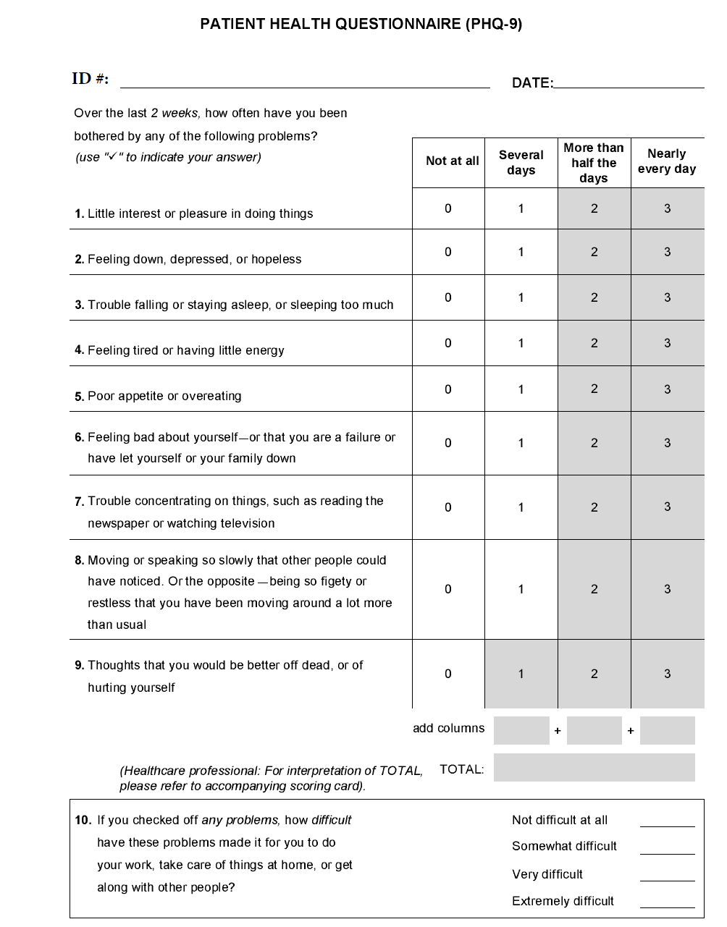
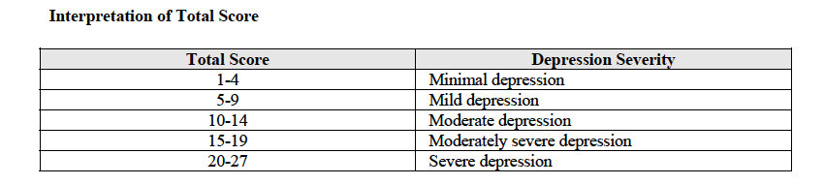

Partial dependence plots
PDPs show how the predicted outcome changes as we vary one feature—averaging out the effects of all other features. In other words, a PDP shows the marginal relationship between a single predictor and the model’s output, holding everything else constant.

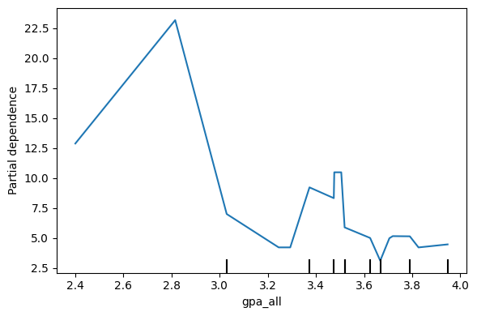
The GPA PDP declines steeply from about a 2.4 to 2.8 GPA, indicating that small grade improvements in the low‑GPA range correspond to large drops in predicted depression. Between 2.8 and 3.1 GPA the curve continues down more gradually, and above 3.1 it flattens out entirely.
Helping struggling students raise a C‑average into the B‑range may yield substantial mental‑health gains, but further GPA boosts beyond a solid B appear to have diminishing returns for depression risk.

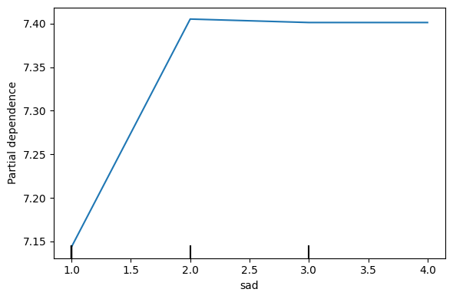
The sadness PDP shows a roughly linear, gently upward slope: each one‑unit increase in self‑reported sadness adds a small, consistent increment to predicted depression.
Increases in momentary sadness, even if modest, reliably elevate overall depression risk; routine mood check‑ins could therefore catch at‑risk students before scores cross clinical thresholds.
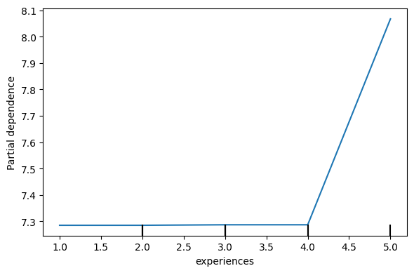
In our partial‑dependence plot for experiences, the predicted depression score remains essentially flat at around 7.3 for response levels 1–3 (“Not at all” to “Moderately”), then jumps sharply to about 7.5 at 4 and to roughly 8.1 at 5 (“Extremely open to new experiences”). Holding all other factors constant, this indicates that only when students rate themselves as highly open and curious does the model predict a noticeably higher depression score.
Openness to new experiences alone isn’t uniformly protective—in fact, extreme openness may coincide with greater emotional sensitivity or risk‑taking that elevates depression risk. Support programs should therefore recognize that highly “experiential” students, while engaged, may also need extra resilience‑building resources.

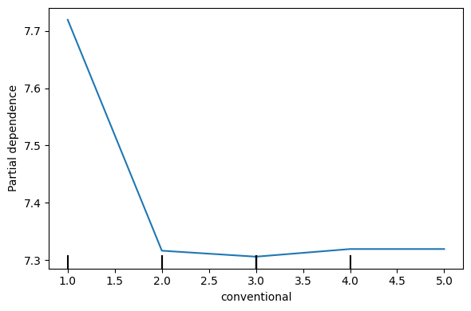
For the conventional scale, the plot shows a drop in predicted depression when moving from 1 (“Not at all conventional”) to 2 (“Slightly conventional”), but thereafter the curve is flat across levels 2–5. In other words, adopting even a small degree of structure or routine is associated with a small reduction in depression risk, but further increases in conventionality do not produce additional changes in the model’s output.
Encouraging students to introduce just a basic level of daily routine—such as regular study hours or consistent mealtimes—may yield mental‑health benefits. Pushing for highly rigid schedules, however, appears unnecessary and unlikely to further reduce depression risk.

Optimal XGBoost Parameters
- n_estimators = 300,
- max_depth = 5,
- learning_rate = 0.01,
- subsample = 1.0,
- colsample_bytree = 1.0

- Random Forest Parameters
- n_estimators = 400,
- max_depth = 5,
- min_samples_leaf = 4
- OLS Regression Results
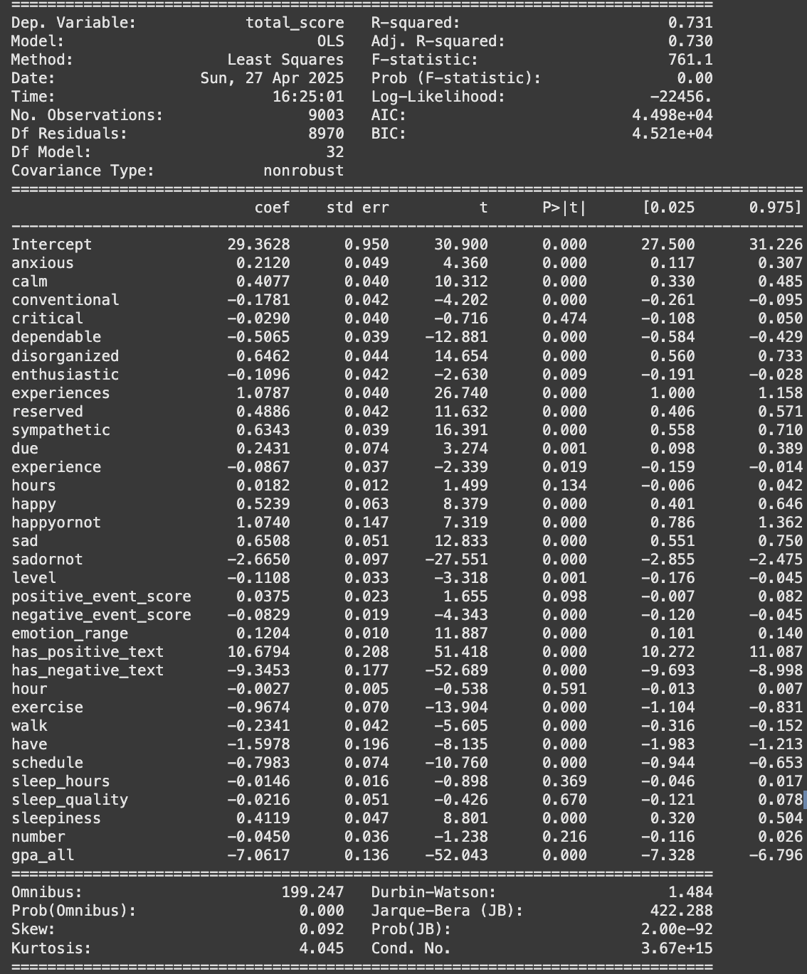

https://pubmed.ncbi.nlm.nih.gov/39963293/

